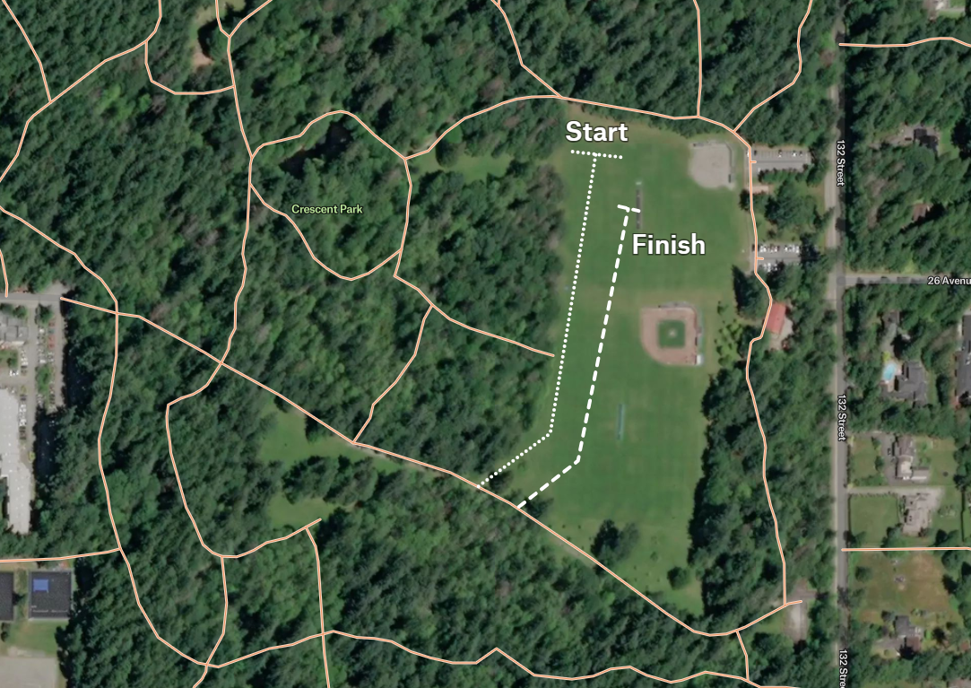
Small Loop
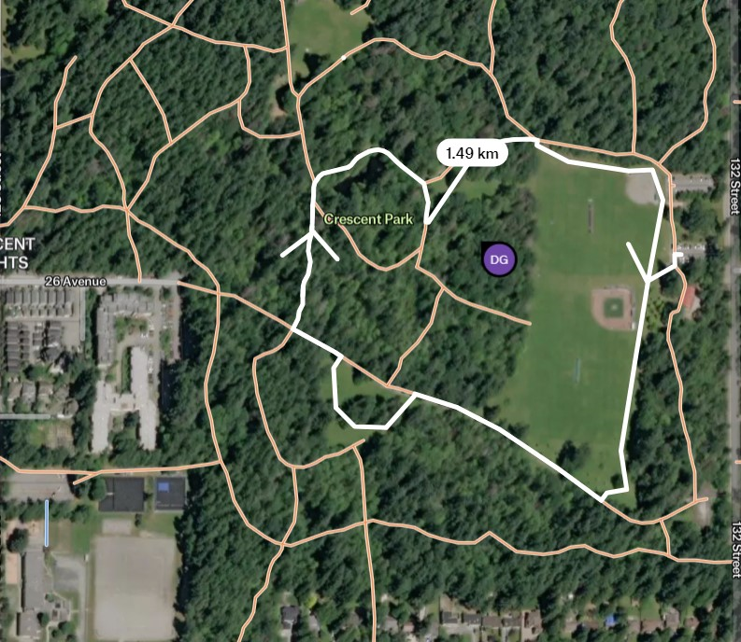

Big Loop

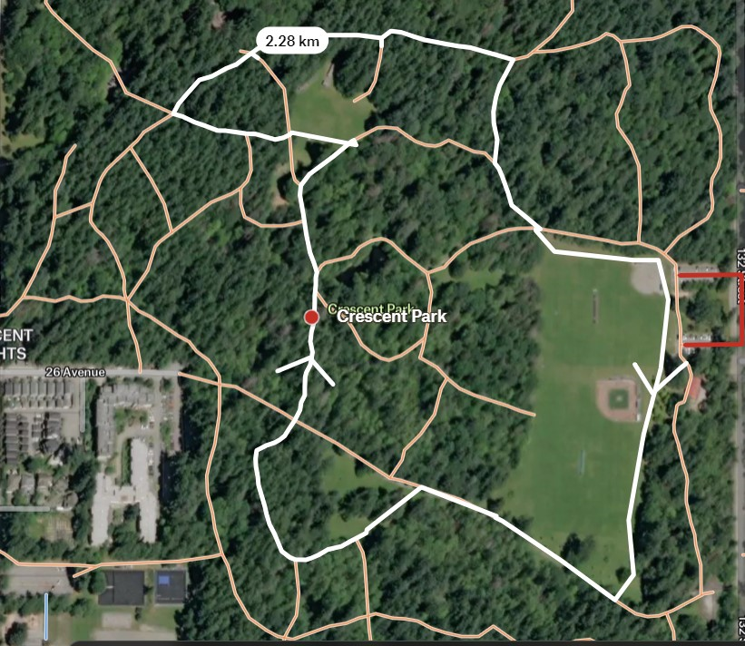

Para: Start, Small Loop, Finish = 2.00 Km
Junior: Start, Small Loop, Large Loop, Finish = 4.22 Km
Senior: Start, 2 x Large Loop, Finish = 5.00 Km

