Fleetwood Park SSSAA League Race #5
Junior & Para: 3:50 Senior: 4:15
Race Notes:
- Maps posted below
- Course will be marked, marshalled, flagged, and have a lead bike.
- Course not suitable for spikes, there are paved sections.
Junior Race

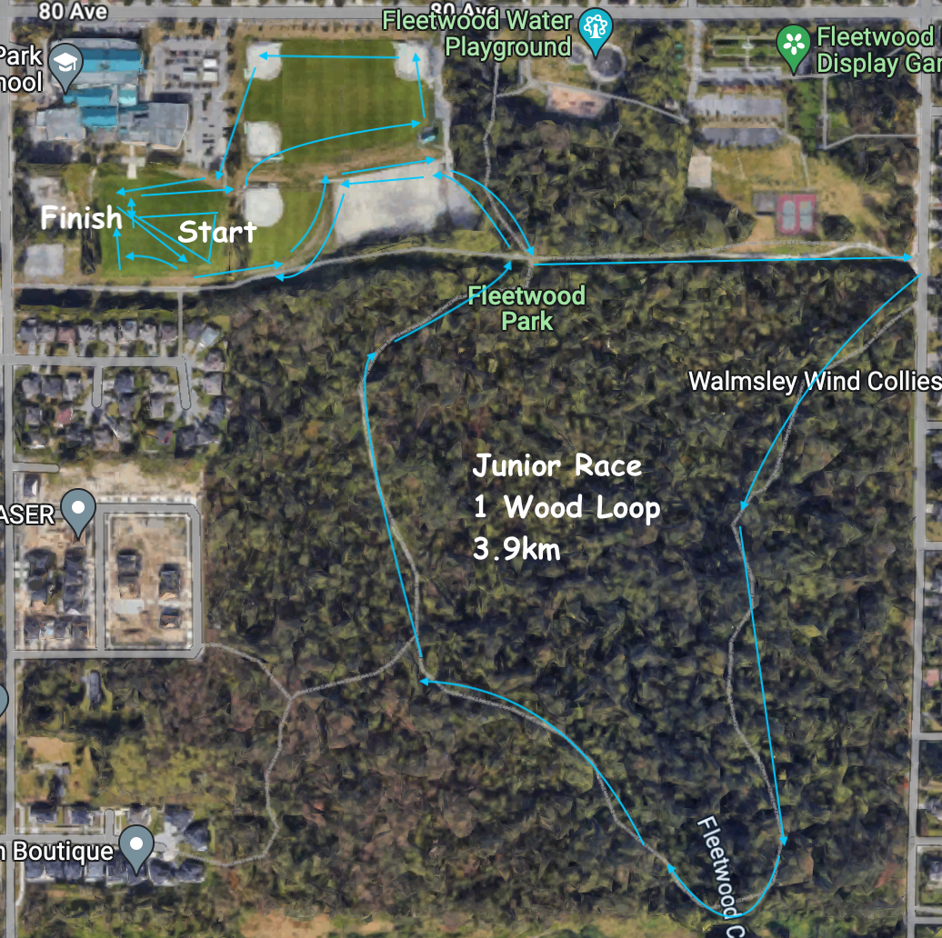

Senior Race

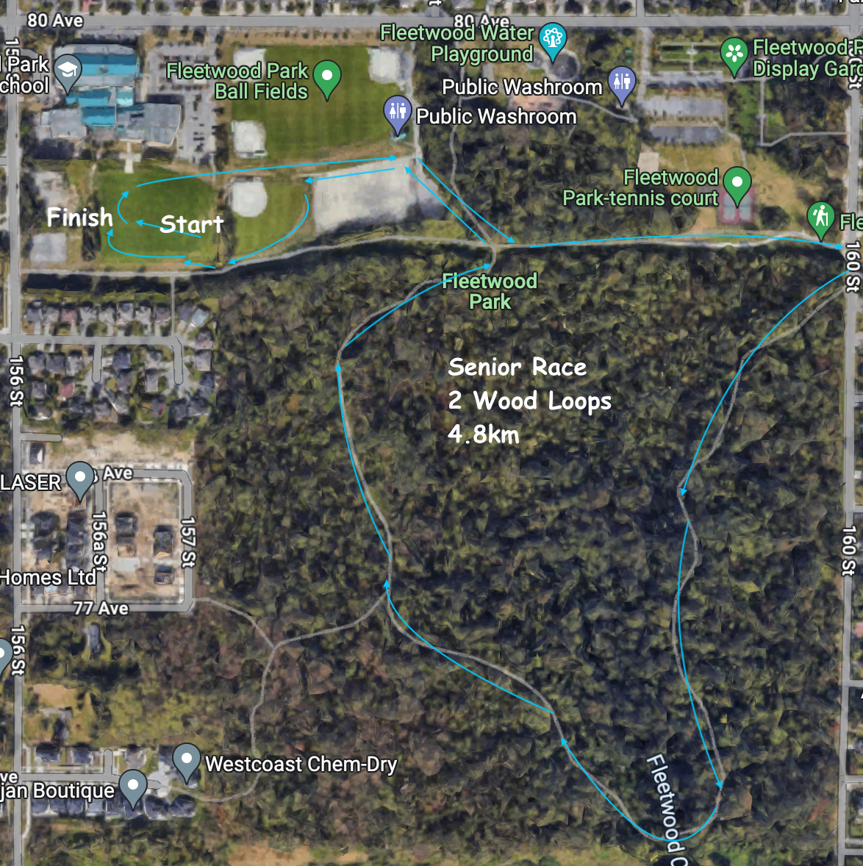

Para Race

