Kwantlen Park SSSAA League Race #4
Junior & Para: 3:50 ​​Senior: 4:15
Race Notes:
- Maps posted below
- All athletes will be given an individual time and place
- Results will be posted at https://southfraserxc.weebly.com/
- Athletes will race with a numbered bib.
- Athletes must be pre-singed up via School coach or AD.
- Course will be marked, marshalled, flagged, and have a lead biker
- Course not suitable for spikes, there are paved sections.
Para-Cross Country Race Notes:
- Athletes will run in Junior race, all grades, and levels welcome.
- Para athletes will be given a race number.
- Contact your school’s BASES or Inclusion Departments for students that may be eligible to participate in this race. We are encouraging lots of athletes to participate this year!
- For more information regarding athletes competing in the Para race, please refer to the PDF attached or the following link: https://southfraserxc.weebly.com/uploads/2/1/3/5/21356954/ac_bchs_xc_para_cross-country.pdf

Para Race — 1x Large Loop (2050m)

Junior Race — 2x Large Loop (4100m)

Senior Race — 1 Small Loop & 2x Large Loop + (4750m)

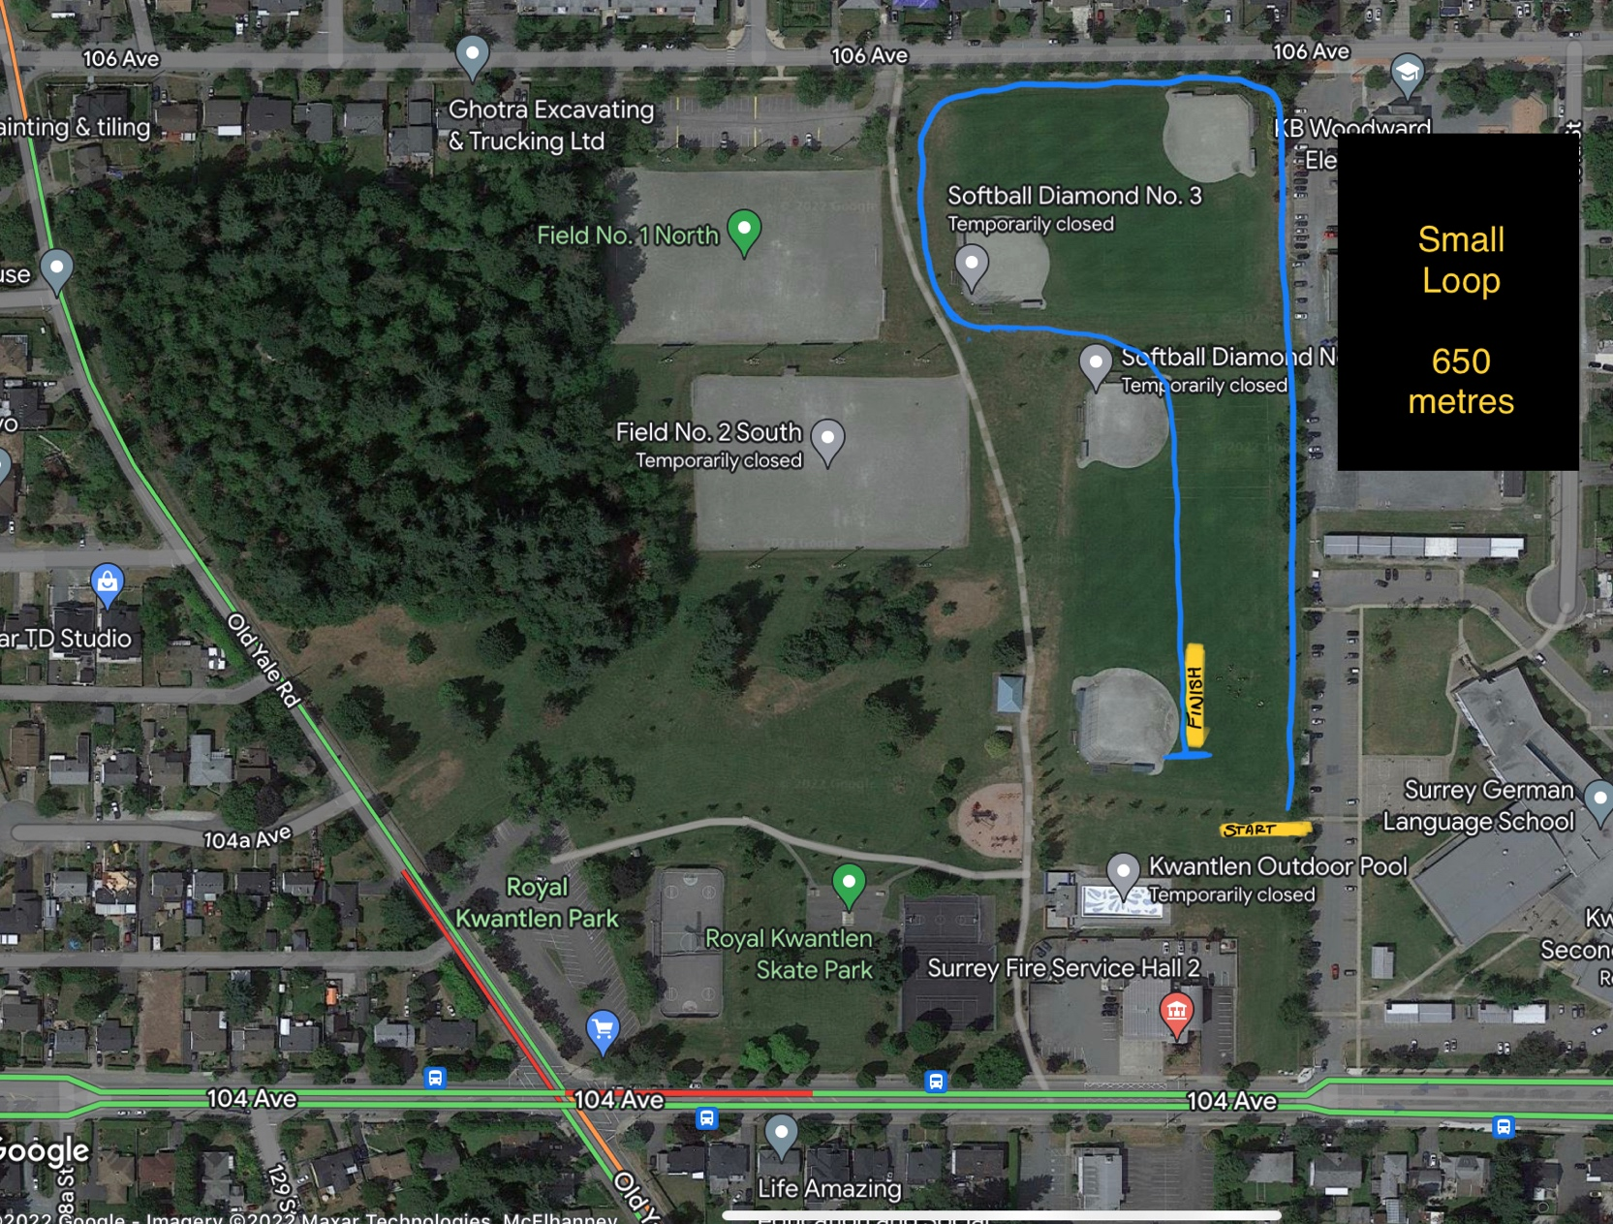
Small Loop (650m)

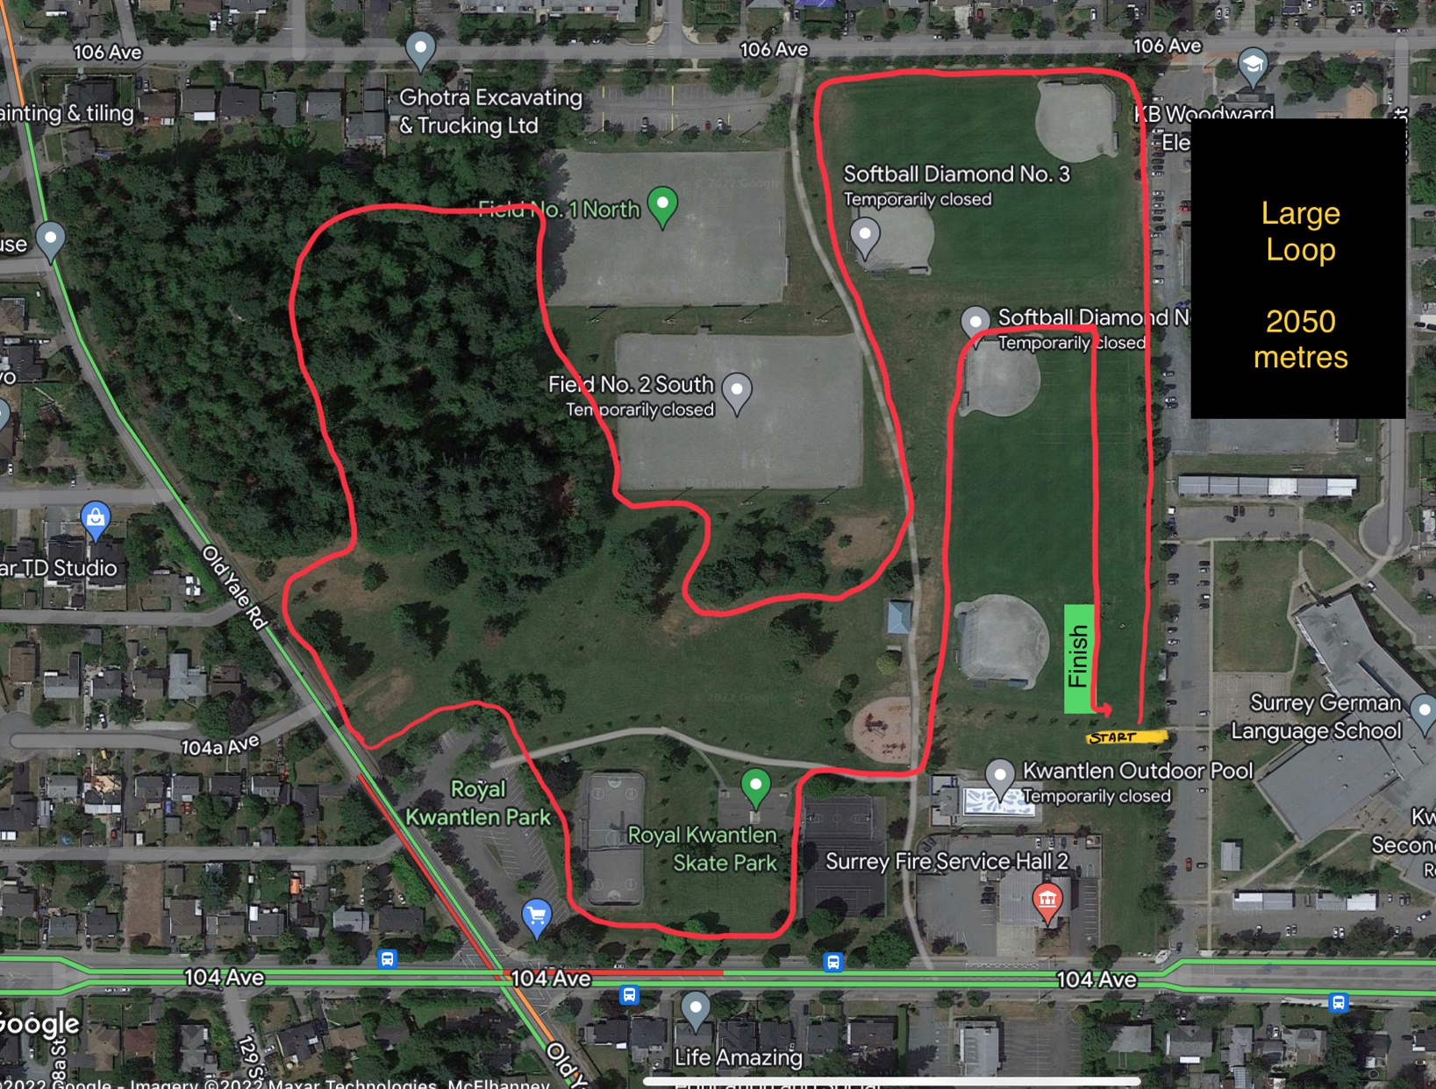
Large Loop (2050m)

