Tamanawis Park League Race #1 2023

Race Notes:

- Maps posted below
- All athletes will be given an individual time and place
- Results will be posted at https://southfraserxc.weebly.com/
- Athletes will race with numbered bib
- Athletes must be pre-signed up
- Course will be marked, marshalled, flagged and have a lead biker
- Course not suitable for spikes, there are paved sections.

Para-Cross Country Race Notes:
- Athletes will run in the Junior race, all grades, and levels welcome.

Finishing Chute Race Notes:

- Boys on the left, girls on the right
- After the finish line stay in order until excused, do not pass someone after the finish line

Para Race - 1.6km - 1 large loop
Junior Race - 3.2km - 2 large loops
Senior Race - 3.7km - 1 small loop, followed by 2 large loops

LONG LOOP - 1.6KM

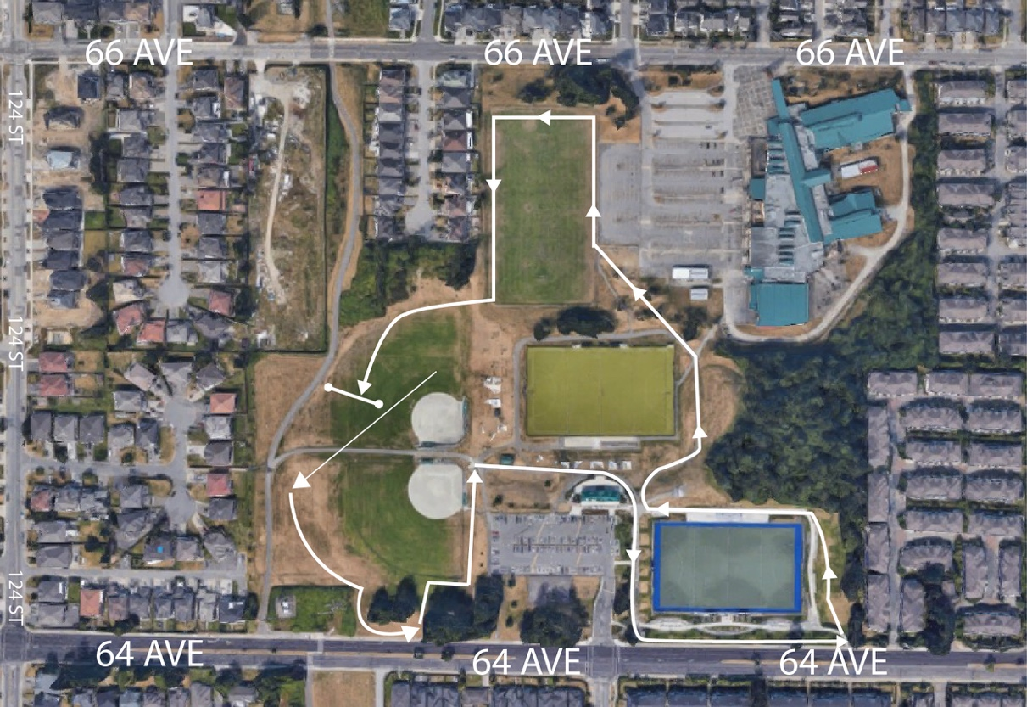

SHORT LOOP - 500M
